Assignments on Java 11

1. Write a program to calculate the Simple Interest with minimal code using features of Java 11.

Hint: Use the concept of functional interface and Local variable syntax for lambda parameters.

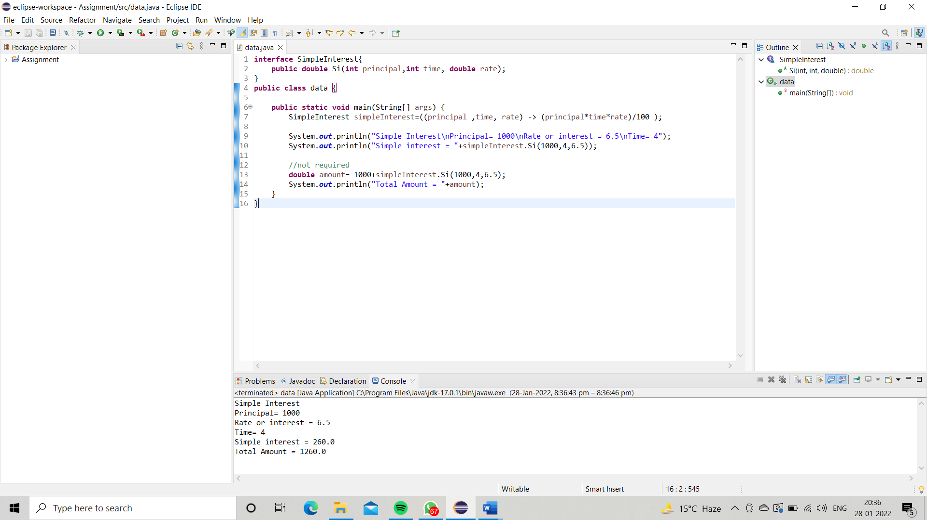

1. Java 11 supports **var** keyword for variable declarations. List the scenarios where **var** keyword cannot be used for such variable declarations. Give reason in support of your answer for each scenario.

Ans: You can use var only for local variables (in methods). It cannot be used for instance variables (at class level). You cannot use var in Lambda expressions.

1. **We can declare any datatype with the** **var keyword**
2. **var can be used in a local variable declaration**
3. **var cannot be used in an instance and global variable declaration.**
4. **var cannot be used as a Generic type**
5. **var cannot be used with the generic type.**
6. **var cannot be used without explicit initialization.**
7. “An apple a day keeps doctor away”. Create an ArrayList from the given String. Such an ArrayList should include each word from the given sentence. Finally convert such List to an array using Java 11 methods and print the output.

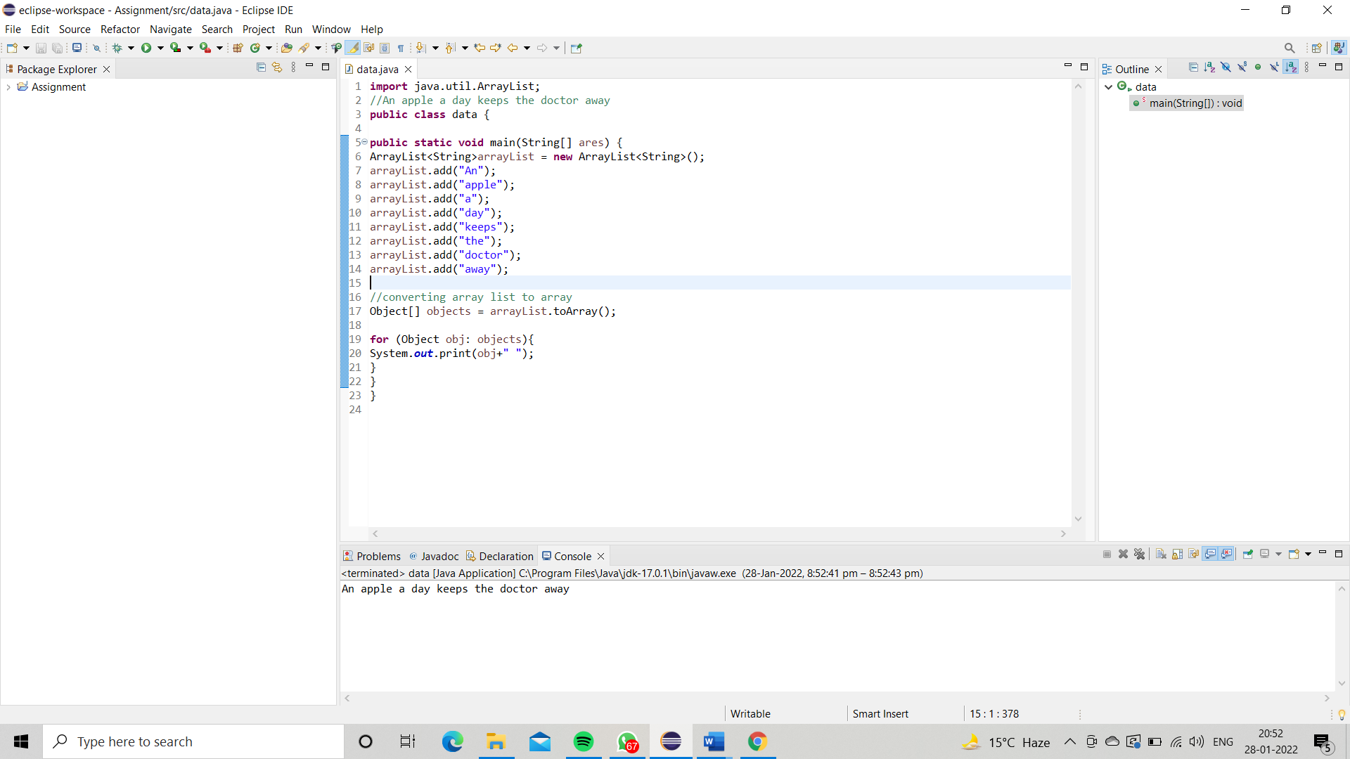

1. Using features of Java 11, read the data from a text file (**File name:** StudentList.txt). Calculate the count of students and print the names as well as the total count of students on the screen. (If any line in file doesn’t contain a name, for such a record blank space should not be printed in the output)

Hint: Use java 11 features of files and String methods to reduce the lines of code to be written.

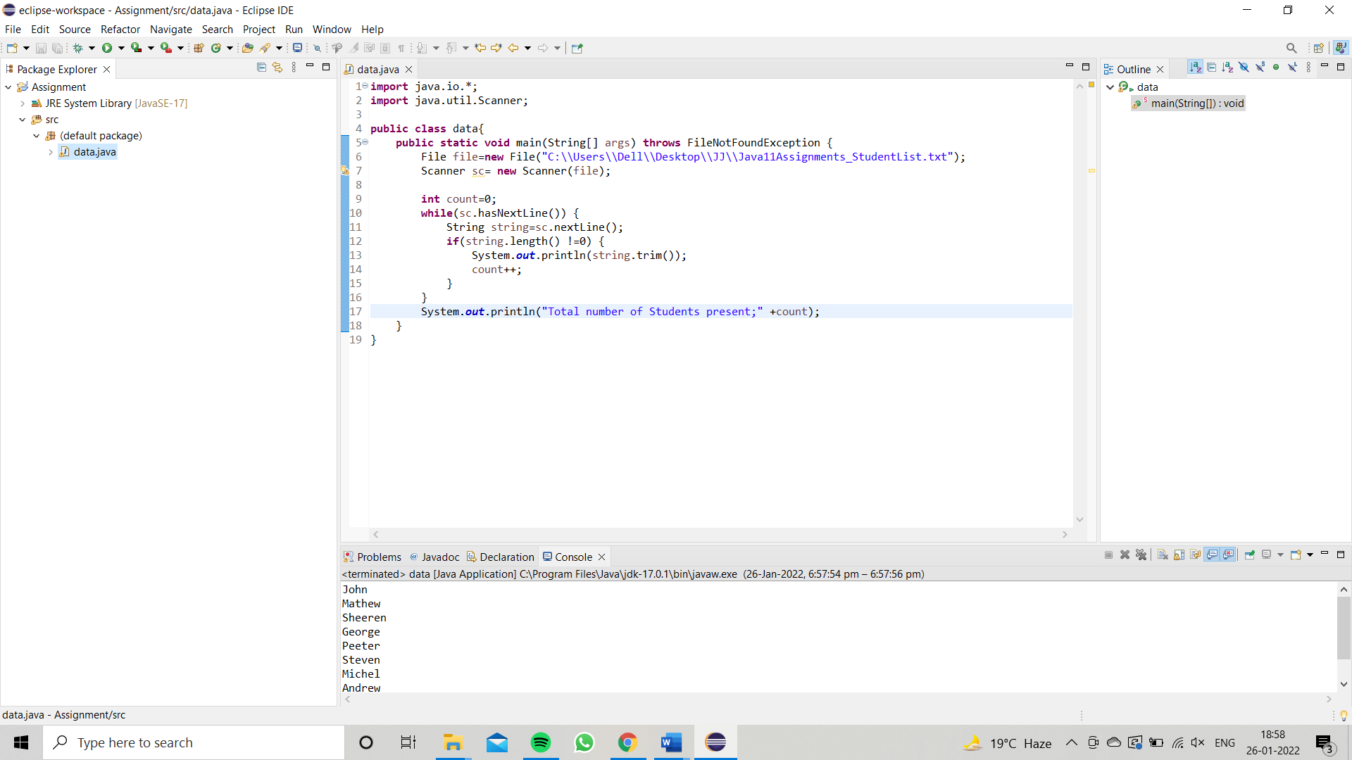

1. Write a program with menu to accept the price of certain items and display their total. When user selects Option 1: should accept the prices of different products and insert these prices into first file (each amount to be inserted in a newline in the file). Next, total of these values should be saved in a new file. Option 2: should allow the user to view the total of these prices from the second file.

**Sample Output**:

Select your option (**1**: Insert New Price, **2**: View Purchase Total, **3**: Exit)

> 1

* + Insert 1st price:

> 100

* + Price has been saved to the file
  + Do you want to enter price for more items? (Yes/No)
  + Yes
  + Insert 2nd price:
  + 200
  + Price has been saved to the file
  + Do you want to enter price for more items? (Yes/No)
  + No
  + Select your option (**1**: Insert New Price, **2**: View Purchase Total, **3**: Exit)
  + 2
  + Total Price of all items is: 300
  + Select your option (**1**: Insert New Price, **2**: View Purchase Total, **3**: Exit)
  + 3

exit program….

Hint: Use java 11 features of files and String methods to reduce the line of code.

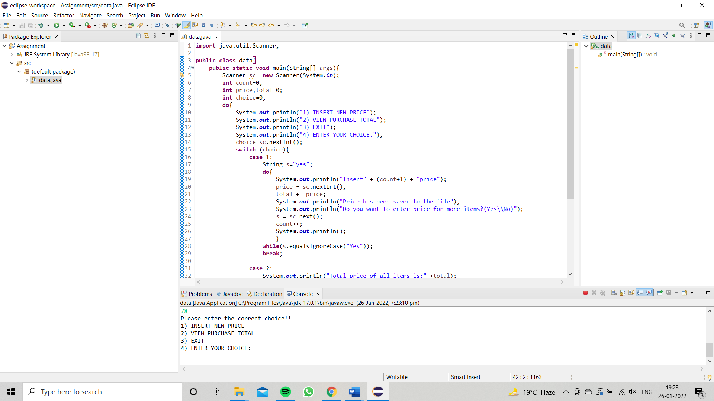

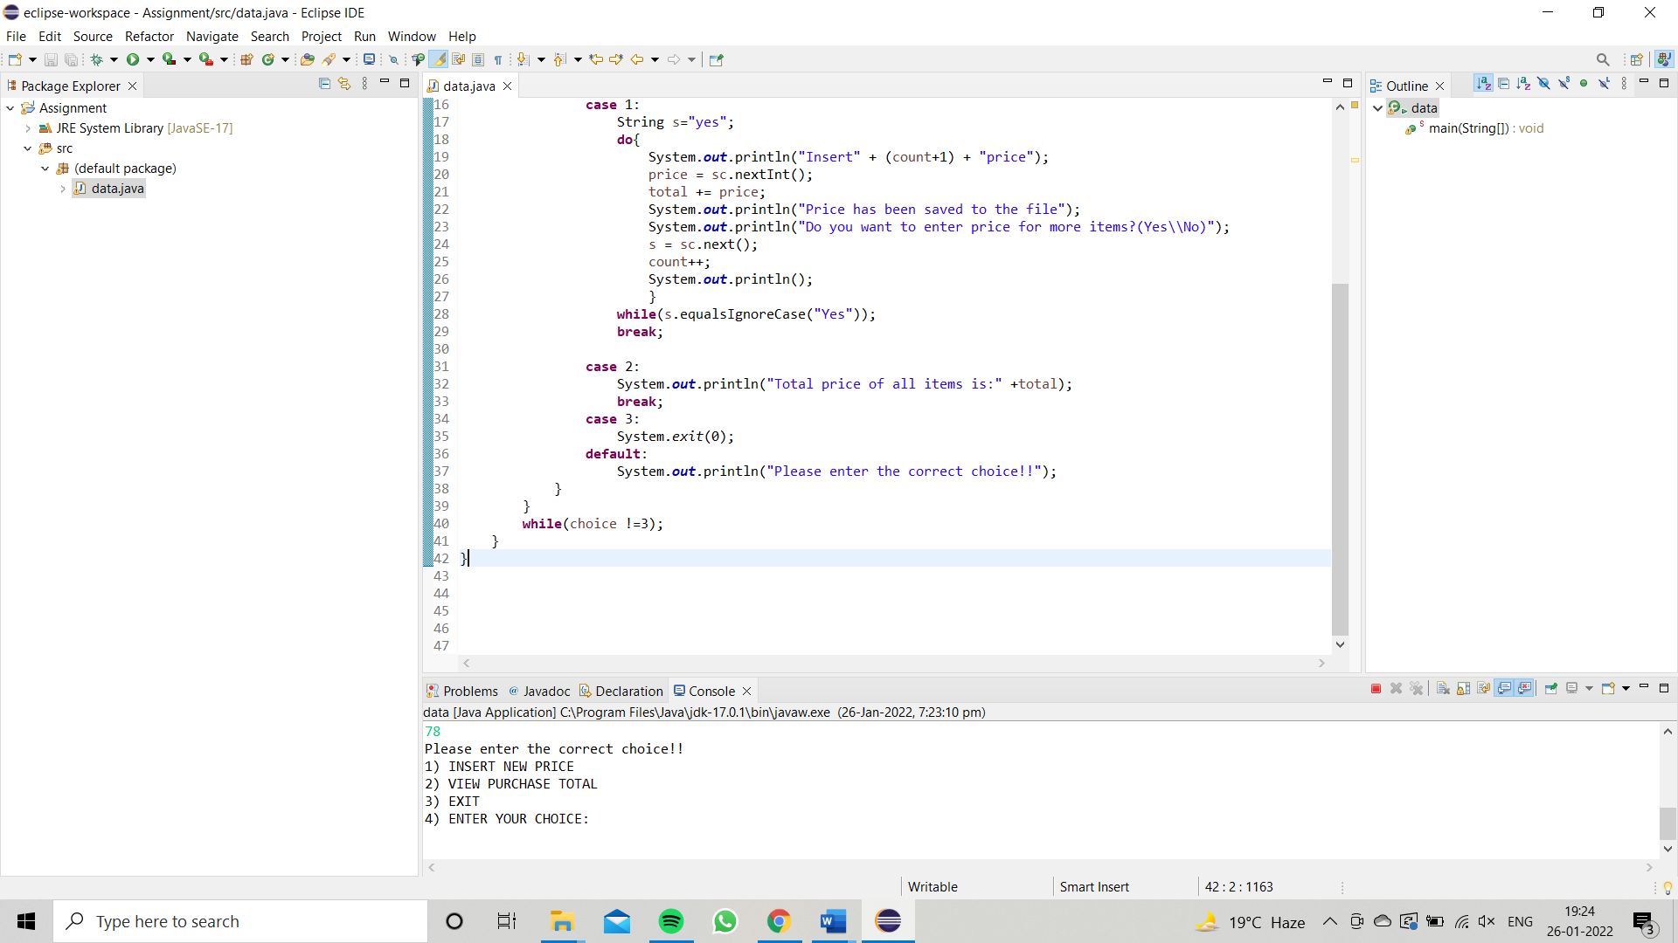

1. Write a code using HttpClient API which sends a GET request

to https://httpbin.org/get, and print out the response header, status code, and body for the given URL.

**Sample output** could be (Note: date and other attribute values may differ in your results):

access-control-allow-credentials:[true] access-control-allow-origin:[*] connection:[keep-alive]

content-length:[273]

content-type:[application/json] date:[Fri, 06 Aug 2021 13:07:41 GMT]

server:[gunicorn/19.9.0] 200

{

"args": {}, "headers": {

"Content-Length": "0",

"Host": "httpbin.org",

"User-Agent": "Java 11 HttpClient Bot",

"X-Amzn-Trace-Id": "Root=1-610d341d-092dc33f698b192a219426d1"

},

"origin": "43.255.221.184",

"url": "https://httpbin.org/get"

}

